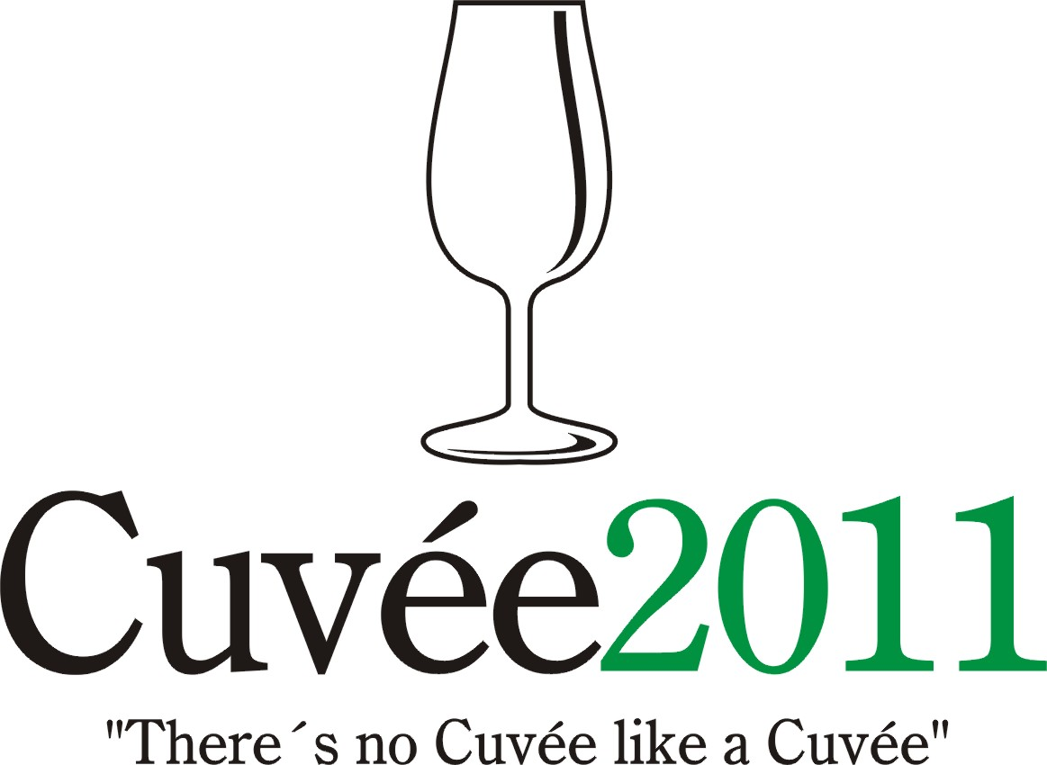

The ninth edition of the singular international competition of coupage, assemblage, blends and branded wines was held on 18th and 28th April in the Club of Ostravan Wine Evaluators, K.AH.A.N., in conjunction with the Ostrava Clarion Congress Hotel and the National Wine Centre which is based in Valtice.

The event takes place under the support of the Wine Fund of the Czech Republic. The specialised warranter and spiritual father of the only wine contest of the Moravian-Silesian district is the guru of Czech and Moravian vini-viticulture Professor Vilém Kraus.

Producers and wine merchants entered a total of 102 individual wines in six competition categories: 21 white dry wines (category A1), 12 white semi-dry and semi-sweet wines (A2), 46 red wines (B), 5 rosé wines (C), 12 sparkling wines (D), 6 liqueur and sweet wines (E). A total of 7 countries had wines in the competition: Czech Republic (64 wines), Slovakia (17), Spain (14), Tunisia (3), Chile (2), France (1), South Africa (1).

Two Specialised Committees under the direction of Professor Fedor Malík and Doc. Miloš Michlovský awarded 10 gold and 20 silver medals. Wine from Moravia were honoured with 4 gold and 10 silver medals. Most successful among the foreign participants were wines from Slovakia (3 gold, 4 silver), followed by Spain (2 gold, 3 silver), Chile (1 gold, 1 silver) and Tunisia (2 silver). No medals were given to the representatives from France or South Africa. The best collection of wines was judged to be that of the Patria Kobylí a.s. winery (1 gold, 2 silver medals).

The title of Champion among the white wines was the Pinot Gris and Sauvignon Blanc from Moravino Grand Cuvée 2009 late harvest (Moravino s.r.o.) from the Mikulov wine sub-region. The Champion in the red-wine category was the Chilean blend of Syrah, Cabernet Sauvignon and Merlot, Tabalí Blends Reserva Especial 2007 (Tabalí / importer Heros Vino s.r.o.) and the prize for the highest-rated red wine of local provenence was Patria Cuvée 2007 special selection of berries (Patria Kobylí a.s.), made with Pinot Noir and Cabernet Sauvignon.

The victor in the white semi-dry and semi-sweet category was Cuvée Klara 2010 Moravian Land Wine (Víno Holec) a coupage of Riesling and Moravian Muscat. The highest rating in the rosé category was received by the Catalan Capita Vidal Rosé Cuvée 2010 (Bodegas Capita Vidal S.L. / imported by vinoteka.es. s.r.o.) produced from the varieties Syrah, Merlot and Garnacha. The winner in the sparkling-wine category was the locally produced Grandioso Demi Sec 2006 (Vinné sklepy Valtice a.s.), from Chardonnay and Riesling grapes. The winner in the liqueur and sweet wine category was from Slovakia Tokaj Saturnia Cuvée 2009 straw wine (J&J Ostrožovič) made from Lipovina and Yellow Muscat.

Concurrently with this contest for the fifth time was the PRIX FIJEV CZ (Special Prize of the International Federation of Journalists and Writers about Wine). The laurels went to Cava Gran Reserva 2004 Fuchs Vidal Cuvée Especial (Bodegas Capita Vidal S.L. / imported by vinoteka.es s.r.o.) and the South African Bilton Sir Percy 2006 (Bilton Wines / importer Staba - Servis Anticor, spol. s.r.o.).

A notional medal and title of Champion was also awarded by the Public Committee. These results are not recognised by the Ministry of Agriculture of the Czech Republic, however, they do permit wine producers and importers to equate the opinions of the specialists with those of the lay public. In accord with the specialised juries, the Public Committee gave its prize to Moravino Grand Cuvée 2009 late harvest (Moravino s.r.o.) and Tabalí Blends Reserva Especial 2007 (Tabalí / importer Heros Vino s.r.o.). As a point of interest sparkling wines received higher marks overall here (the Public Committee awarded 3 gold medals, the special juries gave none) while liqueur and sweet wines on the other hand were less well received by the Public Committee.

The presumptuous aim of the organisers of Cuvée Ostrava is to witness a renaissance of the good name of blends or coupages and their return to the forefront of the products on offer from Czech and Moravian winemakers, similar to the situation in other mature wine-producing nations. In the words of the spiritual father of the competition Professor Vilém Kraus "There's no Cuvée like a Cuvée".

Translation: Helena & John L. Baker

