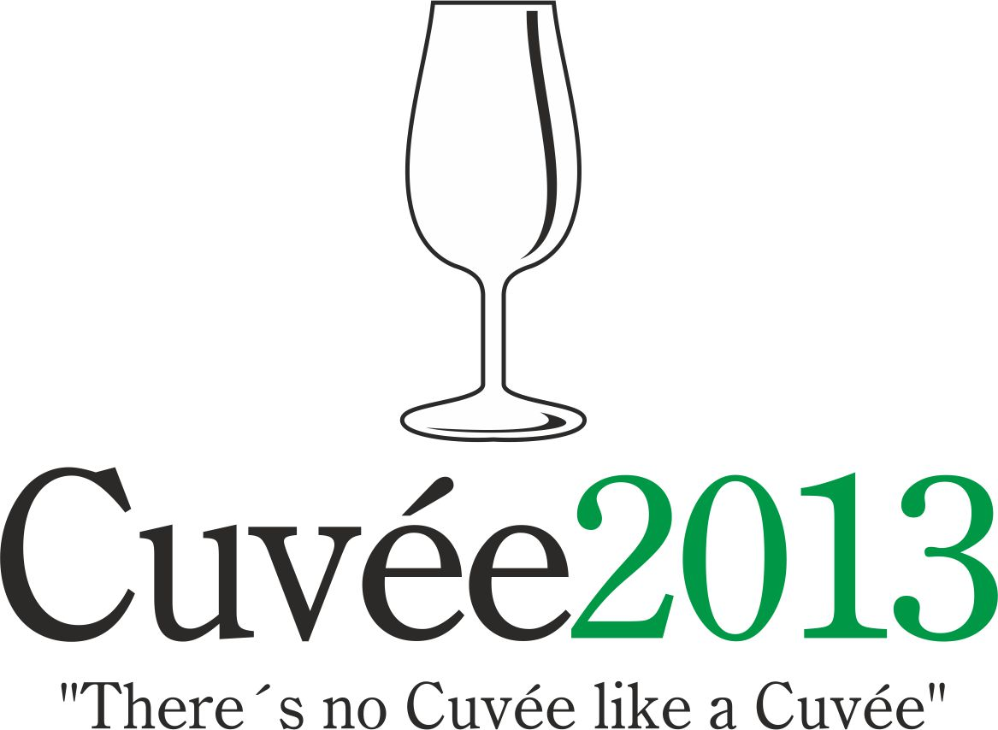

International Wine Competition of the Moravian-Silesian Region
Cuvée 2013 Ostrava

The eleventh edition of this unique international competition of blends and branded wines was held on the 15th and 25th April by the Club of Ostrava’s Amateur Wine Evaluators, K.A.H.A.N. in conjunction with the Zámek Zábřeh Hotel in Ostrava and the National Wine Centre which is based in Valtice.

The event takes place with the support of the Wine Fund of the Czech Republic. The honorary president and spiritual father of the only wine contest of the Moravian-Silesian district is the guru of Czech and Moravian vini-viticulture Professor Vilém Kraus.

Czech and Moravian wine producers and foreign-wine importers entered into this year’s edition a total of 149 wines in six competition categories: 29 white dry wines (category A1), 22 white semi-dry and semi-sweet wines (A2), 65 red wines (B), 13 rosé wines (C), 8 sparkling wines (D) and 10 sweet and liqueur wines (E). A total of 8 countries sent their wines to this competition: Czech Republic (98 samples), Slovakia (16), Spain (13), Poland (11), France (4), Italy (3), Portugal (1) and Chile (1). Wines which fulfilled the conditions of the competition statutes were assessed in the tasting room of National Wine Centre in Château Valtice on 15th April. A hundred-point system was used and only wines receiving 85 or more points were awarded a gold medal. Silver medals were given to wines receiving between 82 and 84.99 points. The organisers were bound by the rules not to award more than 30% of all the wines entered in the competition. The intensity and aromatic profiles for each wine formed part of the comprehensive evaluation of every sample (an average length of 6 minutes for each sample), which serves the producers as better feedback than the simple number of points received.

A quartet of specialised committees under the direction of Professor Fedor Malík, Josef Balík, Bronislav Pavelka and Helena Baker was composed of jurors coming from the Czech Republic, Slovakia, Poland and Great Britain, who awarded 19 gold and 26 silver medals. Local Moravian wines received 11 gold and 14 silver medals. Most successful among the foreign participants were wines emanating from Slovakia (3 gold, 5 silver) and from Spain (3 gold, 2 silver). One gold apiece went to Italy and Chile, whilst two silver medals were received by France, as well as by the somewhat exotic Poland and one silver medal is on its way to Portugal.

The title of Champion among the white wines went to the blend of popular cultivars Chardonnay and Pálava entitled Cuvée Elen 2012 selection of grapes (Pavel Krška – Palavia Vinum, Pavlov) from the Mikulov wine sub-region. Champion in the red-wine category was the Slovak blend of Merlot with the new crossings of Dunaj and Alibernet under the titul of Veterlin 2011 (Elesko a.s., Bratislava). The prize for the highest-rated red wine of local provenence was granted to Bellegrado 2011 (František Zapletal, Břeclav), produced from Cabernet Sauvignon, Alibernet and Merlot grape varieties.

The victor in the other white wines category was the Grüner Veltliner-Traminer 2012 late harvest blend (Wine School and Horticultural College of Valtice). The highest rating in the rosé category was received by Cuvée rosé 2012 moravské zemské víno (Víno Holec, Dolní Dunajovice) made from the Zweigeltrebe, Saint Laurent and Cabernet Sauvignon. The winner in the sparkling-wine category was Znovín de Lux Brut 2009 (Znovín Znojmo, a.s.), Pinot Blanc and Welschriesling cuvée. The winner in the sweet and liqueur wines category was assemblage of Grüner Veltliner, Sauvignon Blanc, Devín and Hetera Tré Ondré 2012 (Víno-Masaryk s.r.o.) from Slovakia. The best overall collection of wines went to the Wine School and Horticultural College of Valtice.

Concurrently with this contest was, for the seventh time, the PRIX FIJEV CZ (Special Prize of the International Federation of Journalists and Writers on Wine). Jurors from the Czech Republic, Slovakia and Poland who are also members of FIJEV nominate those wines chosen from among the competing samples at Cuvée Ostrava that represent the best value for money, together with their intrinsic overall quality. The laureates of the 2013 edition were the Polish Rose Twelve 2012 (Winnica Płochockich, Daromin) made from the Maréchal Foch and Rondo hybrids, together with Italian blend of Merlot and Cabernet Sauvignon Umbria Tegolaro 2007 (Azienda Agraria Carini).

Notional medals and titles of Champions were also awarded at Zámek Zábřeh Hotel on 25th April by the Lay public committee. These results permit wine producers and importers to compare the opinions of the specialists with those of wine aficionados. In total the lay public committee awarded 27 gold and 18 silver medals. The Champions were Cuvée 2009 Moravské land wine (Nesyt Lake Wines, Mikulov) a blend of white grape varieties in which the Pinot Blanc dominated and Chilean assemblage of Cabernet Franc and Petit Verdot Anke Blend 1 2008 Reserva (Santa Alicia / imported by Víno Hruška s.r.o.). The highest rated red wine of local provenance was Bellegrado 2011 jakostní (František Zapletal, Břeclav). Víctors in the individual categories were: Jurigov Ausbruch 2008 (Polnohospodárske družstvo Vajnory; the rosé blend of Saint Laurent and Lemberger Lázeňské cuvée 2012 (Patria Kobylí a.s.); Jaworek Miner 2011 (Winnice Jaworek, Miękinia), an off-dry brand wine from Poland made from the Traminer cultivars and the sparkling wine predominantly featuring the Pinot family bearing the name Charles Sealsfield Brut Klaret 2008 (Znovín Znojmo, a.s.). The best overall collection of wines according to the opinion of the public went to the Patria Kobylí, a.s..

The results from this, the one and only international wine competion taking place in Northern Moravia were made public on 26th April 2013 at the Cuvée Ostrava Wine Exhibition in Zábřeh castle. Professor Fedor Malík inaugurated the accompanying programme for the general public with his traditional tutored tasting of “Slovak wines at 5 o‘clock“. Thereafter the wine exhibition was made accessible to the public to the accompaniment of Moravian dulcimer music and where visitors could sample not only the wines from the competition, but also varietal wines from those Moravian winemakers and importers of foreign wines who were present. The accompanying programme culminated with Joaquín Gay de Montellá Estany (Bodegas Torre del Veguer) and Bonfill Arché Pagès (Celler Arché Pagès) with their “Wines from the Land of Salvador Dalí“.

The presumptuous aim of the organisers of Cuvée Ostrava competition is to witness a renaissance of the good name of blends or brands and their return to the forefront of the products on offer from Czech and Moravian winemakers, as is customary in other major wine-producing countries. In the words of the spiritual father of the competition Professor Vilém Kraus: "There's no Cuvée like a Cuvée" meaning that each and every blend is different.

Contact: Dr. Martin Křístek, tel. +420 603 240 661, info@cuvee.cz, www.cuvee.cz

Translation: John L. & Helena Baker

