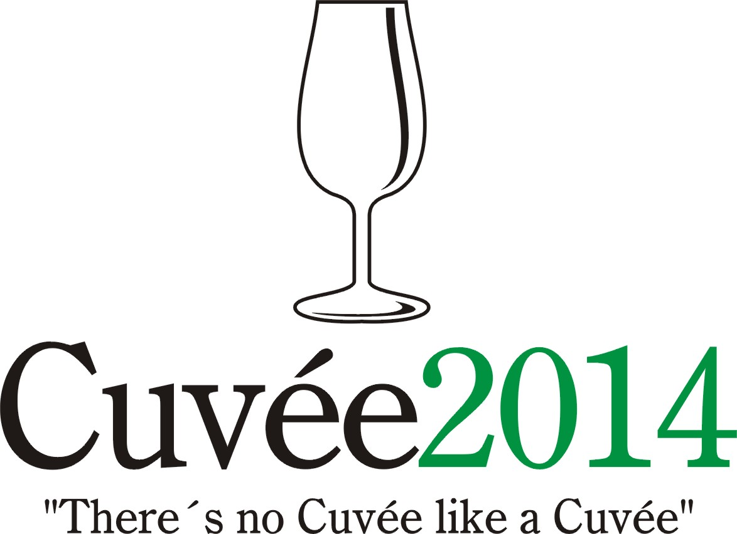

The International Wine Competition of the Moravian-Silesian Region
Cuvée 2014 Ostrava

The twelfth edition of this unique international competition of blends and branded wines was held on the 14th and 24th April by the Club of Ostrava’s Amateur Wine Evaluators, K.A.H.A.N, in conjunction with the Zámek Zábřeh Hotel in Ostrava and the National Wine Centre which has its headquarters in Valtice. The event took place with the support of the Wine Fund of the Czech Republic. The initiator and spiritual father of the only wine contest taking place in the Moravian-Silesian district was the guru of Czech and Moravian vini-viticulture, the late Professor Vilém Kraus, who passed away in June last year.

Czech and Moravian wine producers and foreign-wine importers entered into this year’s edition a total of 117 wines in six competition categories: 24 dry white wines (category A1), 23 semi-dry and semi-sweet white wines (A2), 37 red wines (B), 15 rosé wines (C), 6 sparkling wines (D) and 12 sweet and liqueur wines (E). A total of 8 countries sent their samples to this competition: Czech Republic (65 wines), Slovakia (19), Portugal (8), Spain (7), The Netherlands (6), Poland (5), France (4) and Italy (3). Wines which fulfilled the conditions of the competition statutes were assessed in the tasting room of National Wine Centre in Château Valtice on 14th April. A hundred-point system was used and only wines receiving 85 or more points were awarded a gold medal. Silver medals were given to wines receiving between 82 and 84.99 points. The organisers were bound by the rules not to award more than 30% of all the wines entered in the competition. This regulation was exercised with regard to the individual categories. An integral element of the complex assessment process (an average of 6 minutes per each sample of wine) was the evaluation of the intensity and aromatic profiles of each wine being judged, details which serve better to provide feedback for the producers than simply offering them the number of points received.

A quartet of specialised committees under the direction of Professor Fedor Malík, Josef Valihrach, Bronislav Pavelka and Helena Baker, and including, among others, Darrel Joseph, Central-European correspondent of the Decanter magazine, alongside other experienced jurors, such as Radomil Baloun and Alois Masaryk, was composed of jurors coming from the Czech Republic, Slovakia, Poland, USA and Great Britain. These awarded a total of 20 gold and 19 silver medals. Local Moravian wines were honoured with 8 gold and 12 silver medals. Most successful among the foreign participants were wines emanating from Slovakia (7 gold, 1 silver) followed by Portugal (1 gold, 3 silver). A sensation came in the 2 gold medals awarded to the exotic wine-producing nation of The Netherlands, whilst 2 silvers go to Italy and 1 gold to Spain.

The title of Champion among the dry-white wines went to a blend of the popular cultivars Chardonnay and Riesling entitled Grand Cuvée 2013 Selection of Grapes (Moravíno s.r.o) from the Mikulov wine sub-region. Champion in the red-wine category was the cuvée Premium HF 2011 (Vino Hort s.r.o.), a blend of the Syrah and Grenache grapes which had ripened in southern France in the wine region of Corbières. The prize for the highest-rated red wine of local provenance was granted to Cuvée Filip Barrique 2011 Moravian Vin de Pays (Richard Tichý, Hrušky), being a coupage of newly crossed cultivars Nitra, Dunaj, Dornfelder and Neronet.

The victor in the category of semi-dry and semi-sweet white wines was the blend of Chardonnay, Pinot Blanc and Pinot Gris EGO No. 57 2012 (Zámecké vinařství Bzenec s.r.o.). The winning wine in the rosé category was Rosé Franoir 2013 late harvest (Stanislav Čevela family winery, Strážovice) made from Frankovka (Blaufränkisch), Pinot Noir and Merlot. The winner in the sparkling-wine category was Torelló Reserva Brut 2009 (Torelló / importer Vinoteka.es s.r.o.), a Catalan mix of Macabeo, Parellada and Xarel-lo. The winner in the category for sweet and liqueur wines was the Tokaj selection 6-puttonyos 2006 (Tokaj & Co, s.r.o, Malá Tŕňa), produced from the dried berries of Furmint, Hárslevelü and Yellow Muscadelle, which at the same time became the winner of the award for the best overall collection of wines.

Concurrently with this contest was, for the eighth time, the PRIX FIJEV CZ (Special Prize of the International Federation of Journalists and Writers on Wine). Wines having most engaged the FIJEV members who served on the juries for their exceptional qualities and attractive pricing, wine-making performances, in other words, wines that show the road winemaking should be taking. The laurels for the 2014 edition were shared by the Dutch Rosé Frederique 2013 landwijn (Wijnhoeve de Colonjes, Groesbeek) made with two new crossings Cabernet Colonjes and Regent, and the Moravian sparkling wine from Riesling, Welschriesling and Pinot Blanc Crémant de Spielberg (Spielberg CZ s.r.o., Archlebov).

Notional medals and Champion titles were also handed out at Zámek Zábřeh Hotel on 24th April by the Committee of the Lay Public. These results permit wine producers and importers to compare the opinions of the specialists with those of wine aficionados. The lay public's Champion was in accordance with that of the specialists: Grand Cuvée 2013 late harvest (Moravíno s.r.o, Valtice), sharing with the Italian cuvée of Merlot with Cabernet Sauvignon Umbria Tegolaro 2009 (Azienda Agraria Carini, Perugia). The highest marks for a locally produced red wine went to the blend Zweigeltrebe / Neronet 2009 late harvest (Vinum Moravicum a.s, Bzenec). Victors in the individual categories also accorded with the specialised juries: the Spanish wine Torelló Reserva Brut 2009 (Torelló / importer Vinoteka.es s.r.o.), followed by the Portuguese Eirados Porto 10 Years Old Tawny (Eirados / importer Vínko Konečný a.s.), the Dutch surprise Rosé Frederique 2013 landwijn (Wijnhoeve de Colonjes, Groesbeek) and the semi-dry Moravian cuvée Roter Traminer / Pálava 2010 selection of grapes (Vinum Moravicum a.s, Bzenec). The best overall collection of wines was also in agreement with the specialists' choice - the firm Tokaj & Co.

The results from this - the one and only international wine competion taking place in Northern Moravia - were made public on 24th April 2014 at the Cuvée Ostrava Wine Exhibition in Zábřeh Castle. Professor Fedor Malík inaugurated the accompanying programme with his traditional tutored tasting of "Slovak wines at 5 o‘clock". Thereafter the wine exhibition was made freely accessible to the general public to the sounds of Moravian dulcimer music, while visitors could sample not only the wines from the competition, but also varietal wines from those Moravian winemakers and importers of foreign wines who were present. The accompanying programme culminated with Marcel Perez Torelló and his discourse on the theme "Cava – A Walk through the History of Sparkling Wines in Catalunya".

The presumptuous aim of the organisers of Cuvée Ostrava competition is to witness a renaissance of the good name of blends or brands and their return to the forefront of the products on offer from Czech and Moravian winemakers, as is customary in other major wine-producing countries. In the words of the spiritual father of the competition Professor Vilém Kraus: "There's no Cuvée like a Cuvée" meaning that each and every blend is different.

Contact: Dr. Martin Křístek, tel. +420 603 240 661, info@cuvee.cz, www.cuvee.cz

Translation: John L. Baker & Helena Baker

